**Final Project Report**

**Modeling the Optimization of Eradication of Ebola Virus Disease**

To:

**Professor Timothy Reluga**

From:

**Jiaqi Li**

**Introduction**

In this project, the main goal is to optimize the eradication of the EVD (Ebola Virus Disease) during the outbreak in Guinea in 2014 and give some models that considers effective medicine and vaccine. The factors in a simple model of spread of Ebola in 2014 mainly consider susceptible population, infected patients, and death from Ebola, while a more complex and realistic model will consider isolation and survivors also as significant factors in addition to the simple model. We also want to ask the question that if we have effective medicine for Ebola treatment and effective vaccine for disease prevention, how would the spread of Ebola change in 2014. The main method for this project is using the compartmental model. Problems concerning the model and real-world situations will also be addressed in this project. In addition, all models made in this project are based on the data of Guinea, recorded by WHO and posted as an open source to public by Centers for Disease Control and Prevention.

**Background**

In December 2013, a disease called Ebola starts to spread in small village of Guinea where nobody had ever realized how fatal such disease can be until March 2014. WHO reported that the origin of this Ebola disease was very likely from wild animals, and the index case of this disease was identified as an 18 years old boy who died from it. As such disease spread rapidly throughout the land of West Africa, it becomes the Ebola epidemic. At the beginning of the epidemic, there is no effective medicine that can cure infected patients and no effective vaccine that can prevent people from getting infected. In this situation, more than ten thousand of people died from Ebola during 2014 to 2015. The only thing that an Ebola patient can do is to get isolated so that less people would be infected by Ebola. Fortunately, scientists successfully developed vaccine that can prevent people from getting Ebola with almost 100% effectiveness. Such success was made in December 2016. Study of special medicine for Ebola treatment is also in process. For now, very few cases of Ebola are found, and the spreading of the disease is under control.

In this project, we want to know how the spreading of Ebola would behave if we have effective vaccine and medicine at the very beginning of the outbreak in Guinea. Also, questions like what people would need to do and what difficulties people would need to face to reduce total number of infection and death would also be interesting to us. To answer these questions, we made several models that can give us a better view when we are trying to do analysis. The following content of this report will address what methods we are using, what models we make, what results we have come up with, and what probable answers for our questions would be.

**Methods and Results**

At the beginning, we want to simulate the spread of the Ebola in Guinea. The most basic model is show as following:

I

$$δ$$

$$v$$

D

S

In this model, S represents the Susceptible Population, I represents the Infected Patients, D represents the Dead from Infected Patients D, $v$ is the spread rate of the Ebola, and $δ$ is the death rate of the Ebola patients. The parameter $v$ is not a constant since the spread rate of the disease will also depend on the exposure rate. Thus, we make $v=β \frac{I+D}{I+S+D}$ where $β$ is the chance of getting infected if one is exposed to infectious disease and $\frac{I+D}{I+S+D}$ is the chance of exposing to infectious disease. The system of differential equations can be written as:

$$\left\{\begin{aligned}\frac{dS}{dt}= -vS \\ \frac{dI}{dt}= vS-δI \\ \frac{dD}{dt}=δI \end{aligned}\right.$$

Then, we try to fit the data with this model so that we can develop a more complex model base on this simple model. In this simple model, we can fit the infection curve well to the data with $β=0.08$, $δ=0.006$, $N=4000$ where N is the population of susceptible population at the beginning. However, this model has the problem that the death rate is growing not as fast as the data shows and the total number of death is exceeding the number of infected people, while the data indicates that the total number of death never exceed the maximum number of infected patients. In this case, we will add two more variables to make the model more realistic and we will also adjust the values of the parameters so that our model can fit the data. The two variables that we consider as significant factors next are Immune Population and Isolated Patients, represented as M and H:

D

S

I

$$δ$$

$$v$$

$$μ$$

$$λ$$

$$σ$$

$$ω$$

$$θ$$

M

H

In this model, we add five more parameters:

$ω$: discover rate of naturally immune people

$σ$: naturally recover rate from infected patients

$λ$: isolation rate from infected patients

$μ$: death rate from isolated patients

$θ$: recover rate from isolated patients

In this model, we can obtain a new system of differential equations as following:

$$\left\{\begin{aligned}\frac{dS}{dt}= -vS-ωS \\ \frac{dI}{dt}= vS-δI-σI-λI \\ \frac{dD}{dt}=δI+μH \\ \frac{dM}{dt}=ωS+σI+θH \\ \frac{dH}{dt}=λI-θH-μH\end{aligned}\right.$$

In H, isolated patients will receive necessary medical care that can slow the deteriorate rate of Ebola. This means that $θ$ will be much larger than $σ$. Also, we will still use the formula $v=β \frac{I+D}{I+S+D}$ because immune people will be immune to Ebola for life and will not infect others, and isolated people will not be able contact any others outside the isolation camps, which means they will not infect other susceptible people. By fitting the model into the data, we have $β=0.06, ω=0.000000001, σ=0.00001, δ=0.003, λ=0.01, μ=0.001, θ=0.004, N=6300$ where N is the susceptible population at the beginning. In this model, $ω$ is extremely small since very rare people are found to be naturally immune to Ebola during the outbreak in 2014. $μ$ is relatively small compared to $δ$ since isolated patients receive better medical care, but the difference is not much since Ebola was still very fatal even with medical care during the outbreak in 2014, which also makes $θ$ to be very small. It is hard for us to estimate the value of $λ$ since there are many factors that can influence infected patient getting isolated, such as some patient were not willing to be isolated and medical supplies were also very limited. So we set $λ=0.01$, which can help our model fit the data well.

In addition, unites of all parameters are in $×$*100 percentage of corresponding population per day* ( $β, ω, σ, δ, λ, μ, θ$ has corresponding population of S,S,S,S,S,S,H).

The simulation with fitting data plot start from August, 2014 are presented as following:

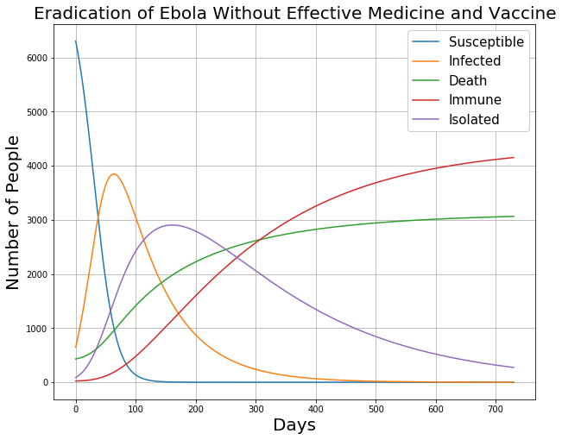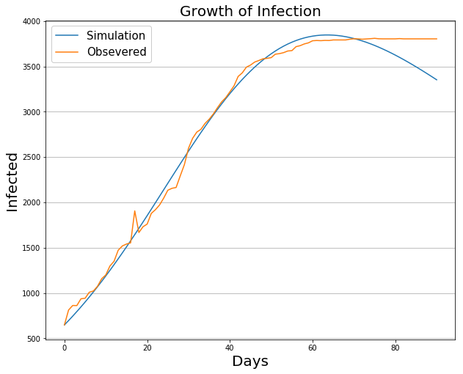

As we can see, this model performs a fair simulation of infection, which can be seen as the spread of the disease. The problem is that in the real data-set, the infected population sustained at around 3500 for a longer period of timer than what our model predicts. When we look at the full information plot of eradication of Ebola (Eradication of Ebola Without Effective Medicine and Vaccine), the prediction makes sense because after about 3 months, many infected patients are isolated, which can control the spread of the disease. As people start to be able to control the spread of the disease, less people will be infected every day and most of the infected patients will be isolated after about 150 days. Number of people who are immune to Ebola also increase and continue to grow after 2 years (730 days). Unfortunately, when we look at the death curve, we can see that number of death reaches at about 3100, which is larger than the real number of death reported by WHO (actual number of death in Guinea is 2536).

Since the prediction we made above starts from August, 2014 when there were already a lot of Ebola patients in Guinea, we also want to take a look at the simulation that performs a full cycle of the spread of the disease. Thus, we want to perform a simulation that starts from the very beginning of the outbreak when only 1 person is infected by Ebola. The following plot gives us a visualization of such simulation:

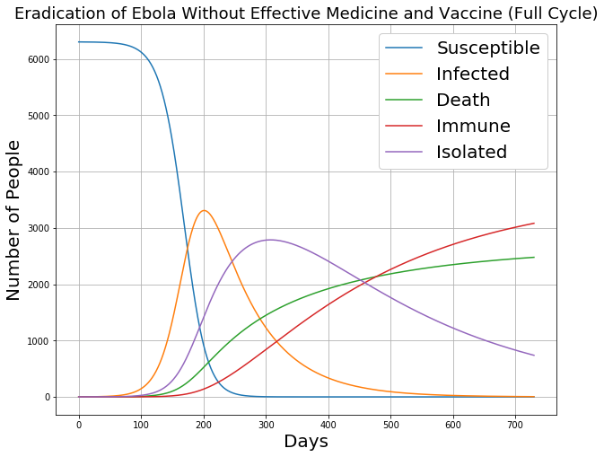

From this plot, we can see that each curve has a shape that is very similar to the former plot except for the day from 0 to 120 since we have a different initial condition for our model. Surprisingly, we find that the total number of death in this simulation reaches around 2500, which are very close to the actual numbers of infected patients and death reported by WHO (death reaches 2536 people cumulatively), and the actual wide spreading of Ebola started after 3 months (about 90 days) as the index case was identified in December 2013. This shows that our model performs a very realistic simulation of the Ebola outbreak in 2014. However, the total number of infected patients decrease to around 3300 at maximum, which is lower than the actual number of infected cases at maximum (actual number is 3804 at maximum).

Next, we want to optimize the eradication of Ebola by assuming that:

1. Effective medicine specially for Ebola Virus Disease is available at the beginning of the outbreak.
2. Effective vaccine specially for Ebola Virus Disease is available at the beginning of the outbreak.
3. People are not willing to pay for Ebola vaccine until new infected cases of Ebola are confirmed and the disease has started to spread.
4. Medicine are given to patients freely and vaccine are sold at a very low price to people in Guinea with sponsor from WHO so that most of the Ebola patients can get fairly effective medical treatment and large percentage of the Guinea’s population can get vaccination.
5. Patients in Guinea are willing to seek for medical help and accept medical treatments.

With these assumptions, we can make some change to the parameters of our model.

One very import change of the parameter is $ω$. Since vaccine is available to Guinea, people will seek for vaccination to prevent getting infected by Ebola. In this situation, $ω$**becomes the vaccination rate of the susceptible population**. Also, since effective medicine is available for patients, $θ$ will also increase. Based on the report of the “Final trial results confirm Ebola vaccine provides high protection against disease” by WHO, the VSV-EBOV vaccine, the first proven vaccine against Ebola virus, can be 80% to 100% effective. Thus, based on such background and assuming that patients infected with Ebola needs to receive such medical treatment at early stage, otherwise the medicine will not be really helpful, **we set $θ=0.6$** .

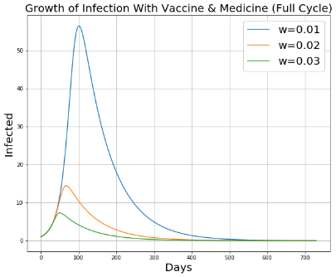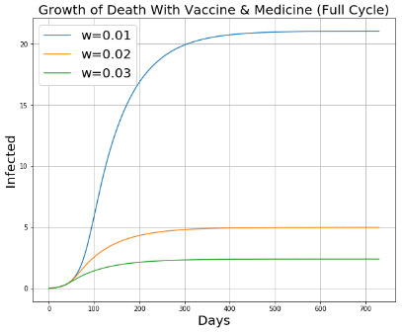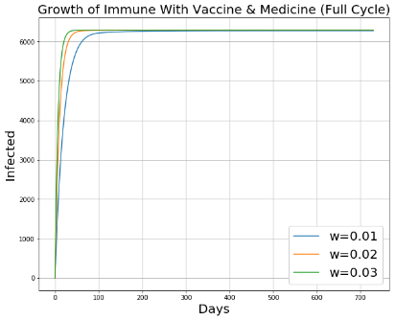

By observing the plot above, we can tell that if $ω=0.01$, there will still be 800 infected patients at maximum and more than 350 people will die from Ebola. When $ω=0.03$, number of people getting infected be Ebola will not exceed 200 and number of death will not exceed 70. We can keep increasing $ω$ until we have very small numbers of infection and death. However, giving more than 3% of susceptible population vaccine per day is not easy. The reason is that once people confirmed that Ebola starts to spread through one area, people will start to panic and try to get vaccine as soon as possible, including both non-susceptible population and susceptible population. People living in some locations that are far from vaccine supply may not be able to get vaccine on time, and these people usually are in poor financial conditions and live in poor hygienic environments.

Finally, we will take a look at the full plot concerning all variables for $ω=0.03$ and $θ=0.6$:

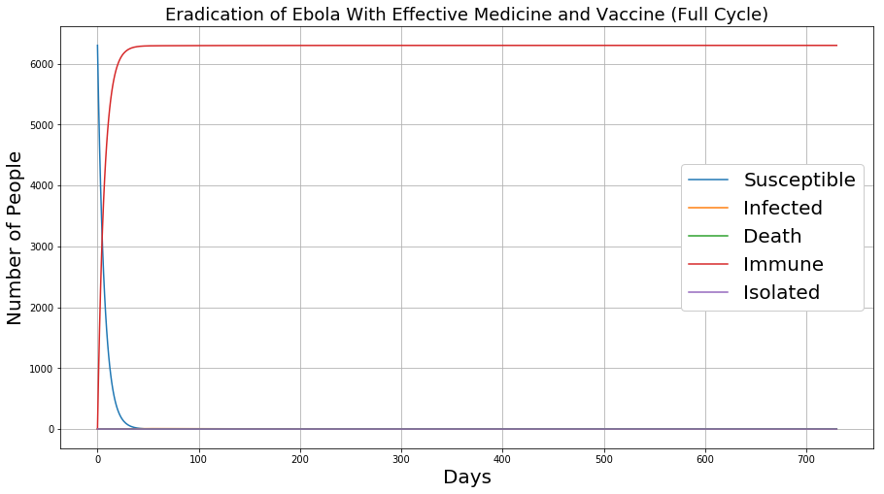

From this plot, we can see that almost all susceptible people will be immune to Ebola in one month. Achieving such success will significantly reduced the death and have fantastic control over the spread of the disease.

**Conclusion and Discussion**

sad